|  |  |  |  |  |  |  |  |  |  |  |  |  |  |  |  |  |  |  |  |  |  |  |  |  |  |  |  |  |  |  |  |  |  |  |  |  |  |  |  |  |  |  |  |  |  |  |  |  |  |  |  |  |  |  |  |  |  |  |  |  |  |  |  |  |  |  |  |  |  |  |  |  |  |  |  |  |
| --- | --- | --- | --- | --- | --- | --- | --- | --- | --- | --- | --- | --- | --- | --- | --- | --- | --- | --- | --- | --- | --- | --- | --- | --- | --- | --- | --- | --- | --- | --- | --- | --- | --- | --- | --- | --- | --- | --- | --- | --- | --- | --- | --- | --- | --- | --- | --- | --- | --- | --- | --- | --- | --- | --- | --- | --- | --- | --- | --- | --- | --- | --- | --- | --- | --- | --- | --- | --- | --- | --- | --- | --- | --- | --- | --- | --- |
| **Name: _____________________________________**  **Roll no:- ___________**    **Index**     |  |  |  |  | | --- | --- | --- | --- | | **Sr.no** | **Experiment Name** | **Date** | **Sign** | |  |  |  |  | |  |  |  |  | |  |  |  |  | |  |  |  |  | |  |  |  |  | |  |  |  |  | |  |  |  |  | |  |  |  |  | |  |  |  |  | |  |  |  |  | |  |  |  |  | |  |  |  |  | |  |  |  |  | |  |  |  |  | |  |  |  |  | |  |  |  |  | |  |  |  |  | |  |  |  |  | |

**Output**

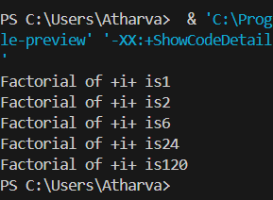

**For Loop**

* **Code**

**// for loop to print factorial of 1 to 5 number**

public class forloopEx

{

public static void main(String args[])

{

int fact=1;

for(int i=1; i<=5; i++)

{

fact*=i;

System.out.println("Factorial of +i+ is" +fact);

}

}

}

**Output**

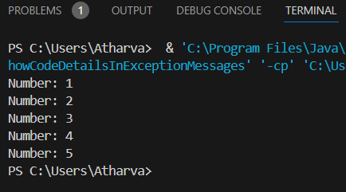

**While Loop**

* **Code:-**

**//prints numbers from 1 to 5**

public class WhileLoopEx {

public static void main(String[] args) {

int i = 1;

while (i <= 5) {

System.out.println("Number: " + i);

i++;

}

}

}

**Output**

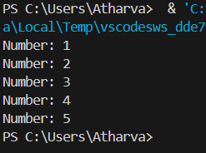

**Do-While Loop**

* **Code:-**

**// do while print 1 to 5 numbers**

public class DoWhileEx {

public static void main(String[] args) {

int i = 1;

do {

System.out.println("Number: " + i);

i++;

} while (i <= 5);

}

}

**Output**

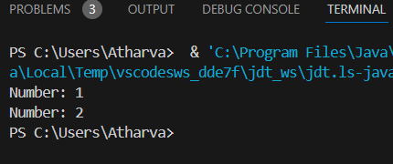

**Break Statement**

* **Code:-**

**// Break statement code**

public class BreakEx {

public static void main(String[] args) {

for (int i = 1; i <= 5; i++) {

if (i == 3) {

break;

}

System.out.println("Number: " + i);

}

}

}

**Output**

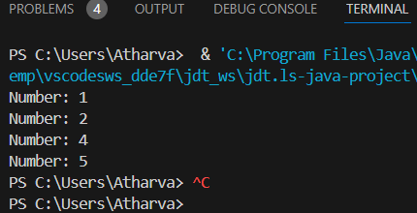

**Continue statement**

* **Code:-**

**//Continue statement Example**

public class ContinueEx {

public static void main(String[] args) {

for (int i = 1; i <= 5; i++) {

if (i == 3) {

continue;

}

System.out.println("Number: " + i);

}

}

}

**Output**

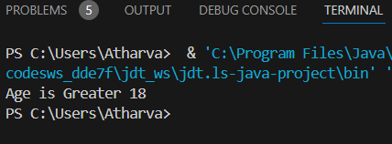

**If Statement**

* **Code:-**

**//if statement code**

class IfEx

{

public static void main(String args[])

{

int age=20;

if(age>18)

{

System.out.println("Age is Greater 18");

}

}

}

**Output**

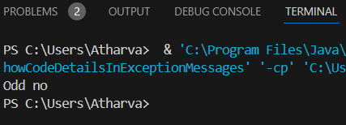

**If-Else Statement**

* **Code:-**

**// If Else statement**

class IfElseEx

{

public static void main(String args[])

{

int num=13;

if(num% 2==0)

{

System.out.println("Even no");

}

else

{

System.out.println("Odd no");

}

}

}

**Output**

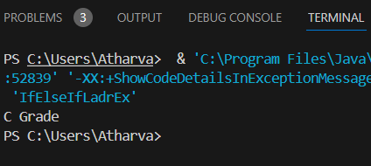

**If-Ese If-Ladder**

* **Code:-**

**//If Else If Ladder statement**

class IfElseIfLadderEx

{

public static void main(String args[])

{

int marks=65;

if(marks<50)

{

System.out.println("Fail");

}

else if(marks>=60 && marks < 70)

{

System.out.println("C Grade");

}

else if(marks>=70 && marks < 80)

{

System.out.println("B Grade");

}

else if(marks>=80 && marks < 90)

{

System.out.println("A Grade");

}

else if(marks>=90 && marks < 100)

{

System.out.println("A+ Grade");

}

else {

System.out.println("Invalid");

} }}

**Output**

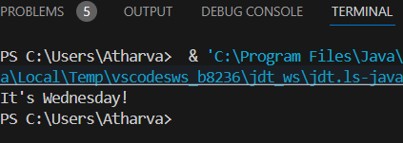

**Switchcase Statement**

* **Code:-**

**public class SwitchCaseExample {**

**public static void main(String[] args) {**

**int day = 3; // Let's say it's Wednesday!**

**switch (day) {**

**case 1:**

**System.out.println("It's Monday!");**

**break;**

**case 2:**

**System.out.println("It's Tuesday!");**

**break;**

**case 3:**

**System.out.println("It's Wednesday!");**

**break;**

**case 4:**

**System.out.println("It's Thursday!");**

**break;**

**case 5:**

**System.out.println("It's Friday!");**

**break;**

**case 6:**

**System.out.println("It's Saturday!");**

**break;**

**case 7:**

**System.out.println("It's Sunday!");**

**break;**

**default:**

**System.out.println("Invalid day!");**

**}}}**

**Output**

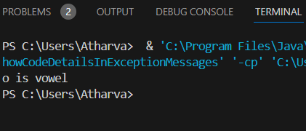

**// Vowel are not using Switchcase**

**public class SwitchCaseExample {**

**public static void main(String[] args) {**

**char ch='o';**

**switch (ch) {**

**case 'a':**

**System.out.println("a is vowel");**

**break;**

**case 'e':**

**System.out.println("e is vowel");**

**break;**

**case 'i':**

**System.out.println("i is vowel");**

**break;**

**case 'o':**

**System.out.println("o is vowel");**

**break;**

**case 'u':**

**System.out.println("u is vowel");**

**break;**

**case 'A':**

**System.out.println("A is vowel");**

**break;**

**case 'E':**

**System.out.println("E is vowel");**

**break;**

**case 'I':**

**System.out.println("I is vowel");**

**break;**

**case 'O':**

**System.out.println("O is vowel");**

**break;**

**case 'U':**

**System.out.println("U is vowel");**

**break;**

**default:**

**System.out.println("It is Not Vowel");**

**}**

**}**

**}**

**Output**

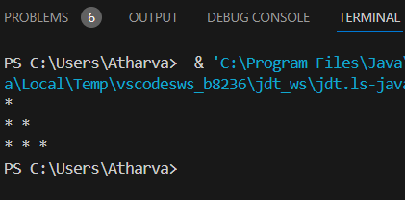

**Right Half Pyramid**

* **Code:-**

**// Right Half Pyramid**

class RightHalfPyramidEx {

public static void main(String[] args) {

int n = 3;

for (int i = 1; i <= n; i++) {

for (int j = 1; j <= n; j++) {

if (j <= i) {

System.out.print("* ");

} else {

System.out.print(" ");

}

}

System.out.println();

}

}

}

**Output**

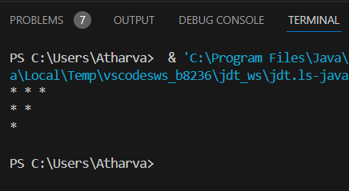

**Inverted Right Half Pyramid**

* **Code:-**

**//Inverted Right half Pyramid**

class InvertedRighthalfPyramidEx

{

public static void main(String args[])

{

int n=4;

for (int i = 1; i <= n; i++) {

for (int j = 1; j <= n; j++) {

if (j <=n-i ) {

System.out.print("* ");

} else {

System.out.print(" ");

}

}

System.out.println();

}

}

}

**Output**

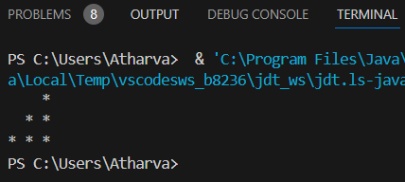

**Left Half Pyramid**

* **Code:-**

**// Left Half Pyramid**

class LeftHalfPyramidEx {

public static void main(String[] args) {

int n = 3;

for (int i = 1; i <= n; i++) {

for (int j = 1; j <= n; j++) {

if (j <= n - i) {

System.out.print(" ");

} else {

System.out.print("* ");

}

}

System.out.println();

}

}

}

**Output**

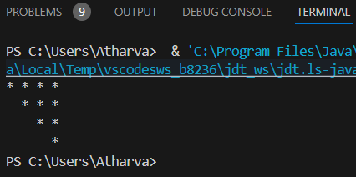

**Inverted Left Half Pyramid**

* **Code:-**

**// Inverted Left Half Pyramid**

class InvertedLeftHalfPyramidEx

{

public static void main(String[] args)

{

int n = 4;

for (int i = 0; i < n; i++) {

for (int j = 0; j < n; j++) {

if (j >= i) {

System.out.print("* ");

} else {

System.out.print(" ");

}

}

System.out.println();

}

}

}

**Output**

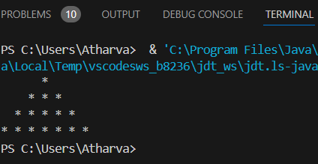

**Full Pyramid**

* **Code:-**

**// Full Pyramid using for loop and if-else**

class FullPyramidEx {

public static void main(String[] args) {

int n = 4;

for (int i = 1; i <= n; i++) {

for (int j = 1; j <= (2 * n - 1); j++) {

if (j >= n - i + 1 && j <= n + i - 1) {

System.out.print("* ");

} else {

System.out.print(" ");

}

}

System.out.println();

}

}

}

**Output**

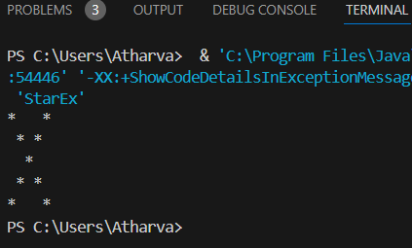

**Cross Star**

* **Code:-**

**public class StarEx**

**{**

**public static void main(String[] args)**

**{**

**int n = 5;**

**for (int i = 0; i < n; i++)**

**{**

**for (int j = 0; j < n; j++) {**

**if (i == j || i + j == n - 1)**

**{**

**System.out.print("*");**

**}**

**else**

**{**

**System.out.print(" ");**

**}**

**}**

**System.out.println();**

**}**

**}**

**}**

**Output**

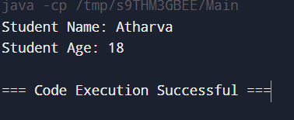

**This KeyWord**

* **Code:-**

**//This keyword code**

class Student {

private String name;

private int age;

public Student(String name, int age) {

this.name = name;

this.age = age;

}

public void displayDetails() {

System.out.println("Student Name: " + this.name);

System.out.println("Student Age: " + this.age);

}

}

public class Main {

public static void main(String[] args) {

Student student1 = new Student("Atharva", 18);

student1.displayDetails();

}

}

**Output**

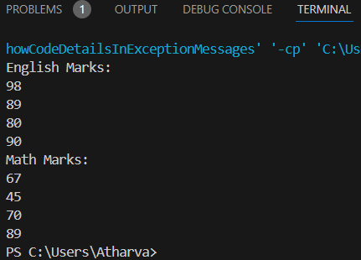

**Array**

* **Code:-**

**//Array Code for to print the marks using 2 for loop**

public class ArrayExpublic

{

public static void main(String[] args) {

int engmarks[] = {98, 89, 80, 90};

int mathmarks[] = {67, 45, 70, 89};

System.out.println("English Marks:");

for (int i = 0; i < 4; i++) {

System.out.println(engmarks[i]);

}

System.out.println("Math Marks:");

for (int j = 0; j < 4; j++) {

System.out.println(mathmarks[j]);

}

}

}

**Output**

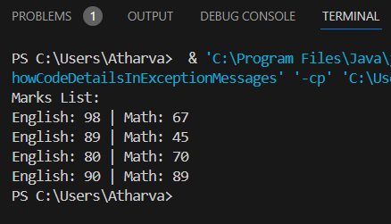

* **Code:-**

**// Array Code for to print the marks Using single for loop**

public class ArrayExpublicc {

public static void main(String[] args) {

int engmarks[] = {98, 89, 80, 90};

int mathmarks[] = {67, 45, 70, 89};

System.out.println("Marks List:");

for (int i = 0; i < 4; i++) {

System.out.println("English: " + engmarks[i] + " | Math: " + mathmarks[i]);

}

}

}

**Output**

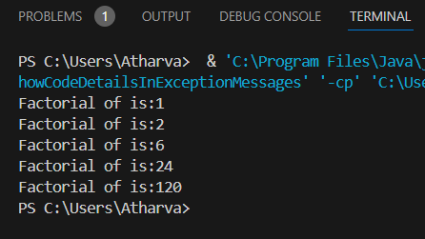

**Factorial num**

* **Code:-**

public class forloopEx

{

public static void main(String args[])

{

int fact=1;

for(int i=1; i<=5; i++)

{

fact*=i;

System.out.println("Factorial of +i+ is" +fact);

}

}

}

**Output**

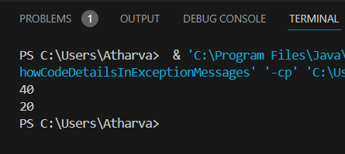

**Swap two num**

* **Code:-**

public class swap{

public static void main(String args[])

{

int a=10;

int b=20;

int temp;

temp=a;

a=b;

b=temp;

System.out.println(a);

System.out.println(b);

}

}

**Output**

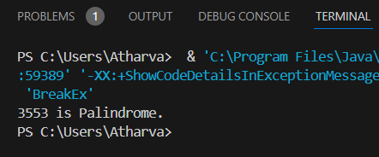

**Palindrom number**

* **Code**

public class SimplePalindromeNoImport {

public static void main(String[] args) {

int num = 3553, reversedNum = 0, remainder;

int originalNum = num;

while (num != 0) {

remainder = num % 10;

reversedNum = reversedNum * 10 + remainder;

num /= 10;

}

if (originalNum == reversedNum) {

System.out.println(originalNum + " is Palindrome.");

}

else {

System.out.println(originalNum + " is not Palindrome.");

}

}

}

**Output**

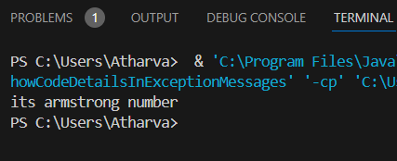

**Armstrong Number**

* **Code:-**

public class a{

public static void main(String[] args)

{

int n= 370;

int temp=n;

int r,sum=0;

while(n>0)

{

r=n%10;

n=n/10;

sum=sum + r*r*r;

}

if(temp==sum)

{

System.out.println("its armstrong no");

}

else

{

System.out.println("its not armstrong no");

}

}

}

**Output**

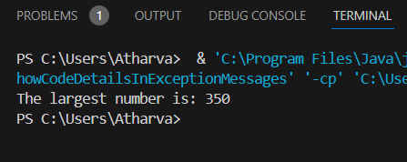

**Largest of three num**

* **Code:-**

public class Largest{

public static void main(String[] args) {

int num1 = 50;

int num2 = 350;

int num3 =10;

int largest;

if (num1 >= num2 && num1 >= num3) {

largest = num1;

} else if (num2 >= num1 && num2 >= num3) {

largest = num2;

} else {

largest = num3;

}

System.out.println("The largest number is: " + largest);

}

}

**Output**

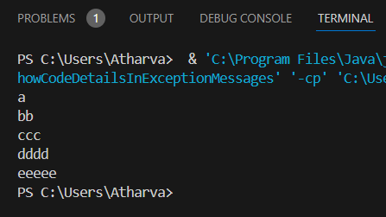

**Pattern program**

* **Code:-**

public class alphabeticpattern {

public static void main(String[] args) {

char[] arr = {'a', 'b', 'c', 'd','e'};

for(int i = 0; i < 5; i++) {

for(int j = 0; j <= i; j++)

{

System.out.print(arr[i]+"")

}

System.out.print("\n");

}

}

}